3. Write program demonstrates how to perform morphological analysis using the NLTK library in Python.
Aim: To perform morphological analysis by converting words into their dictionary root forms using NLTK.
Procedure:
- Install NLTK using python -m pip install nltk.
- Import the WordNet lemmatizer.
- Download the WordNet dataset.
- Provide words with their parts of speech.
- Display the root forms.
Code:
import nltk
nltk.download('wordnet', quiet=True)
from nltk.stem import WordNetLemmatizer
lem = WordNetLemmatizer()
words = ["cars", "playing", "studies", "ate"]
print("Original Word - Root Word")
print("cars -", lem.lemmatize("cars", pos="n"))
print("playing -", lem.lemmatize("playing", pos="v"))
print("studies -", lem.lemmatize("studies", pos="v"))
print("ate -", lem.lemmatize("ate", pos="v"))
Output:
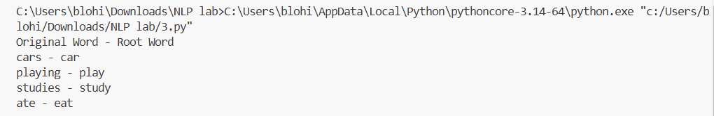
Result: Morphological analysis was performed successfully using NLTK lemmatization.

